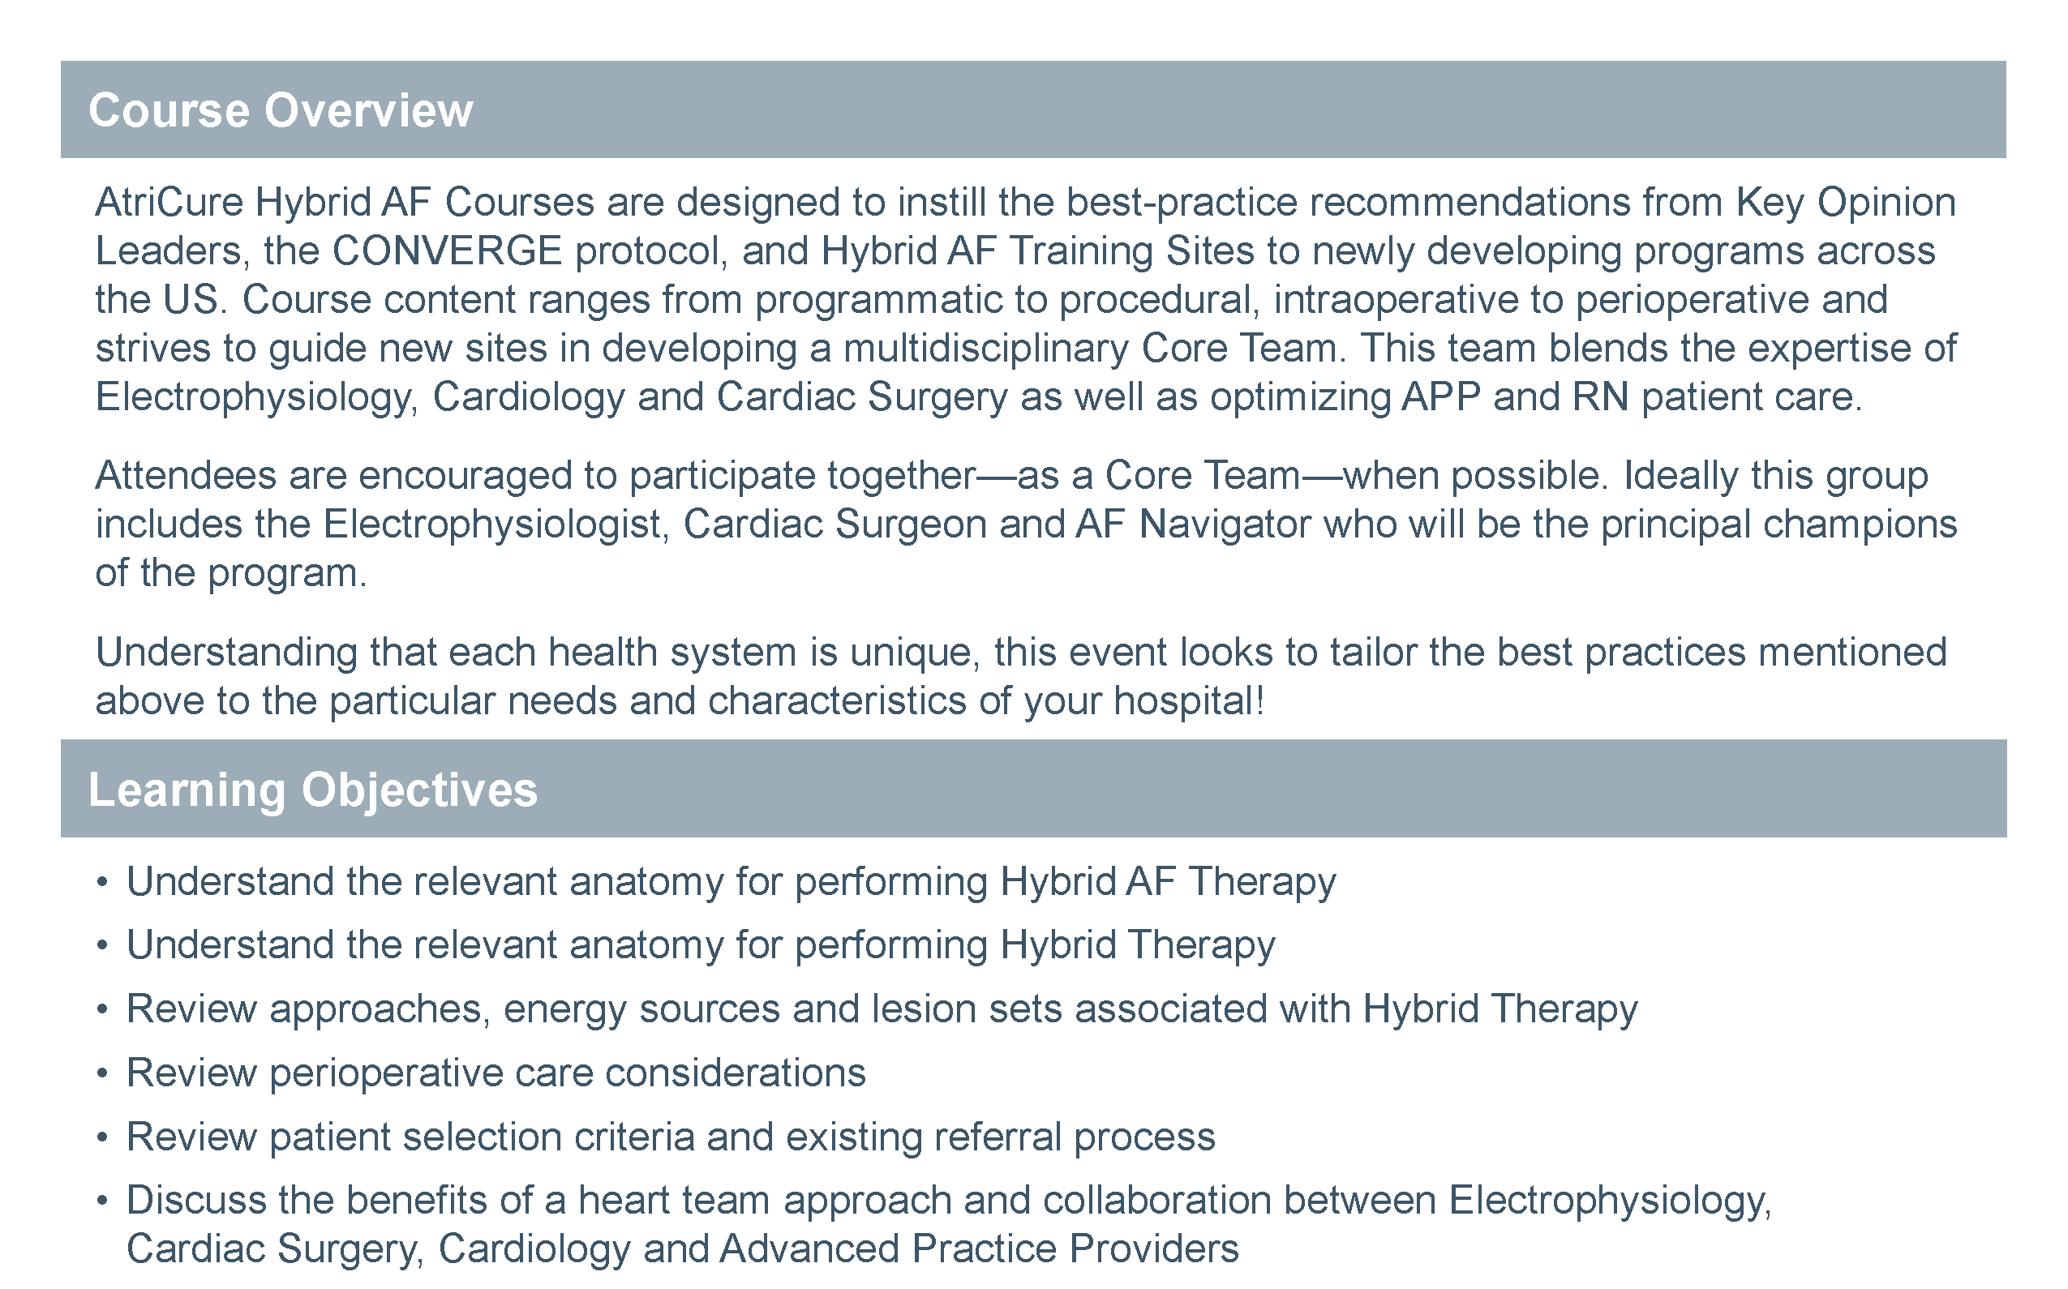

|  |
| --- |
| Agenda:  Presenters: |

**Hybrid AF Therapy for Advanced Afib**

Presented by

**Date:**

Location: