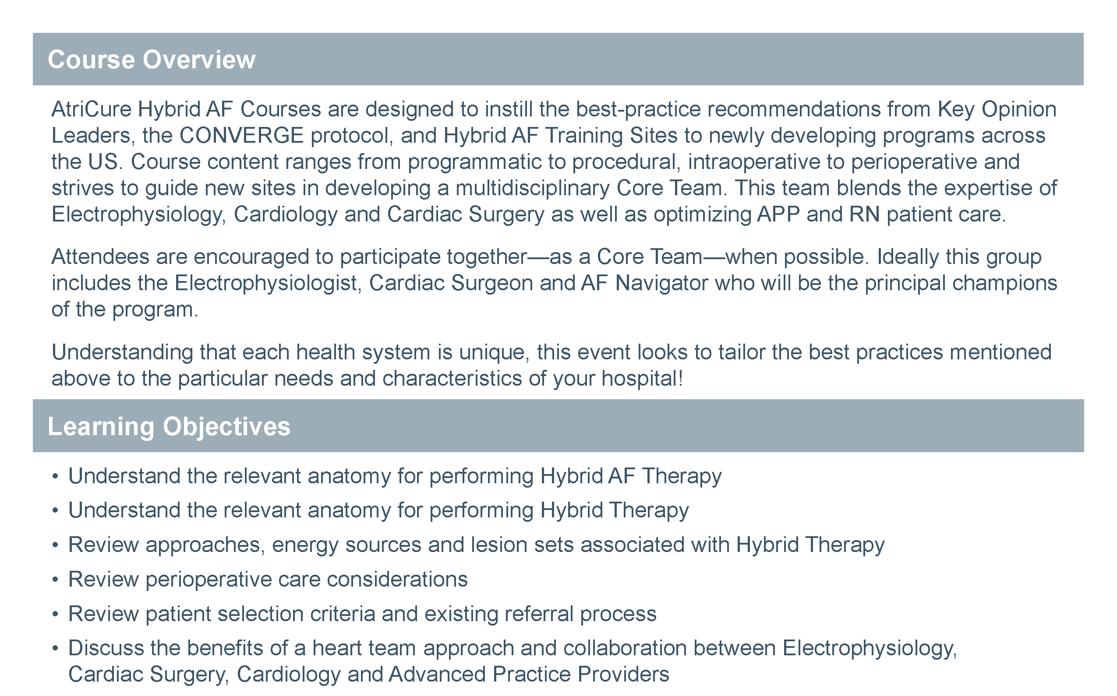

|  |
| --- |
| Two Sessions Available:  7:00 – 9:00 am Didactic Session, Suite 230 *(breakfast will be served)*  9:30 – 11:30 am Hands-on Lab Training, Suite 240  Jack Randell, MD  Clinical Professor of Electrophysiology, Director of Atrial Fibrillation Wellness Program  Eugene Jenkins, MD  Clinical Professor of Cardiothoracic Surgery, Director of Adult Cardiac Surgery QA & QI and Safety Director |

**Hybrid AF Therapy for Long-Standing Persistent Afib**

Presented by Jack Randell, MD & Dr. Eugene Jenkins, MD

**Thursday, January 14, 2021**

Heart & Vascular Building: Suite 320